Heaven’s Light is Our Guide

Department of Computer Science & Engineering
Rajshahi University of Engineering & Technology

Lab Manual

Course Title: Sessional based on CSE 4119
Course No.: CSE 4120
Credit: 0.75

Reference Book:
[1] Jiawei Han, Micheline Kamber, and Jian Pei, “Data Mining: Concepts and Techniques”

Experiments/Problems:
[Week 1] Introduction to Data Mining and Tools
Objective: Understand basic data mining concepts and tools.
Topics: Data types, tasks (classification, clustering, association).
Tools: Weka, Python, or Orange.
Datasets:
- Iris Dataset – Classification, clustering
- Online Retail – Association rule mining (market basket) and Clustering
- House Prices – Regression

Tasks:
- Install Python libraries (e.g., Pandas, scikit-learn, Matplotlib).
- Explore datasets using pandas.

Lab Outcomes:
- Load dataset (in .csv or .xlsx format):
- Iris Dataset
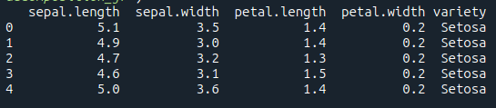

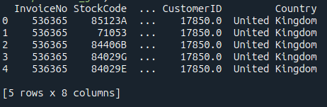
- Online Retail

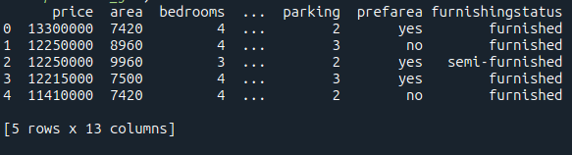
- House Prices

- Try to understand the data type. Determine the dimensions of the data.
- Find out which one you can use as a label.
- Try different ways to split the data into training, validation, and test sets (60% training, 20% validation, and 20% test data).
- Identifying the dependent and independent variables.
- Split into two sets: features and labels.
- Identifying the number of labels and showing them. Plot them using Matplotlib.
- Based on the labels categorised, what type of problem is this: classification, multiclass classification, regression or clustering?

